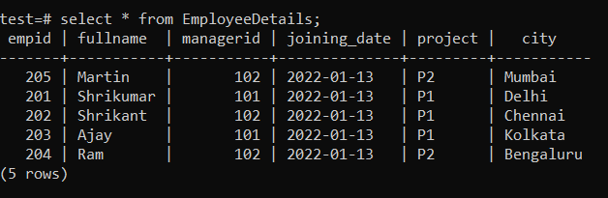

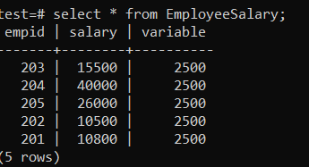

Q1. Write an SQL Query to fetch the Empid and FullName of all the employees working under Manager with id 101.

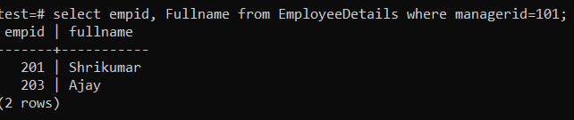

Q2. Write an SQL query to fetch the count of employees working in project ‘P1’.

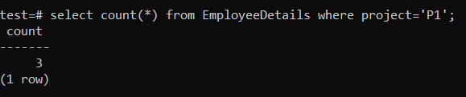

Q3. Write an SQL query to find the maximum, minimum and average salary od the employees

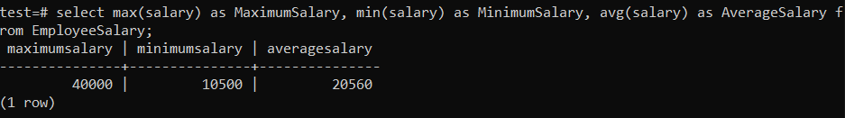

Q4. Write and SQL query to find the employee if whose salary lies in the range of 10000 and 15000.

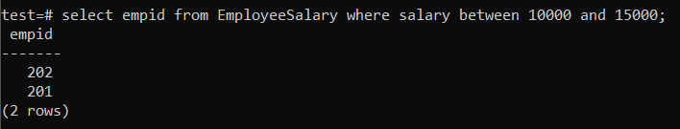

Q5. Write an SQL query to display the total salary of each employee adding the Salary with Variable value.

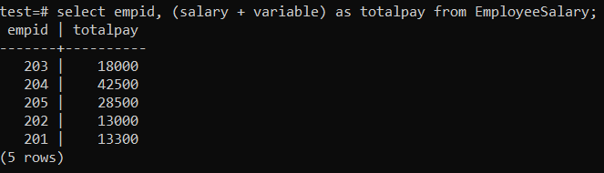

Q6. Write an SQL query to fetch the Empids that are present in both the tables – EmployeeDetails and EmployeeSalary

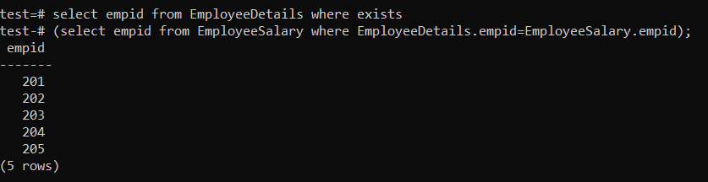

Q7. Write an SQL query to upper case the name of the employee and lowercase the city values.

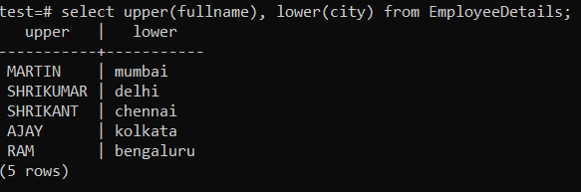

Q8. Write and SQL query to fetch project-wise count of employees sorted by project’s count in descending order.

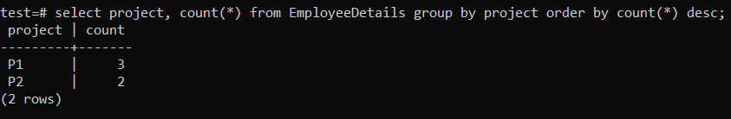

Q9. Write an SQL query to fetch only odd rows from the table.

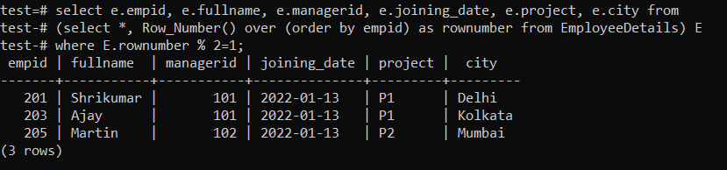

Q10. Write SQL Query to find the 3rd highest salary from a table without using the TOP/limit keyword.

